**Gear Ratios**

*Diametral Pitch - number of gear teeth for each inch (25.4 mm) of pitch diameter*

*=* ***4 for each gear***

$\frac{no. of Teeth}{Diametral Pitch}= pitch diameter (inches)$

1st Gear: 3:1

Teeth: 54: 18

* Output: 54/4 = 13.5 (in) = 342.9 mm

radius = 171.45 mm

* Input 18/4 = 4.5 (in) = 114.3 mm

Radius = 57.16 mm

2nd Gear: 2:1

Teeth: 48:24

* Output: 48/4 = 12 (in) = 304.8 mm

radius = 152.4 mm

* Input 24/4 = 6 (in) = 152.4 mm

Radius = 76,2 mm

3rd Gear: 1.25:1

Teeth: 40: 32

* Output: 40/4 = 10 (in) = 254 mm

radius = 127 mm

* Input 32/4 = 8 (in) = 203.2 mm

Radius = 101.6 mm

4th Gear: 1.00:1

Teeth: 36: 36

* Output: 36/4 = 9 (in) = 228.2 mm

radius = 114.3 mm

* Input 36/4 = 9 (in) = 228.2 mm

Radius = 114.3 mm

5th Gear: 0.85:1

Teeth: 34: 40

* Output: 34/4 = 8.5 (in) = 215.9 mm

radius = 171.45 mm

* Input 40/4 = 10 (in) = 254 mm

Radius = 127 mm

6th Gear: 0.54:1

Teeth: 24:44

* Output: 24/4 = 6 (in) = 152.4 mm

radius = 76.2 mm

* Input 44/4 = 11 (in) = 279.4 mm

Radius = 139.7 mm

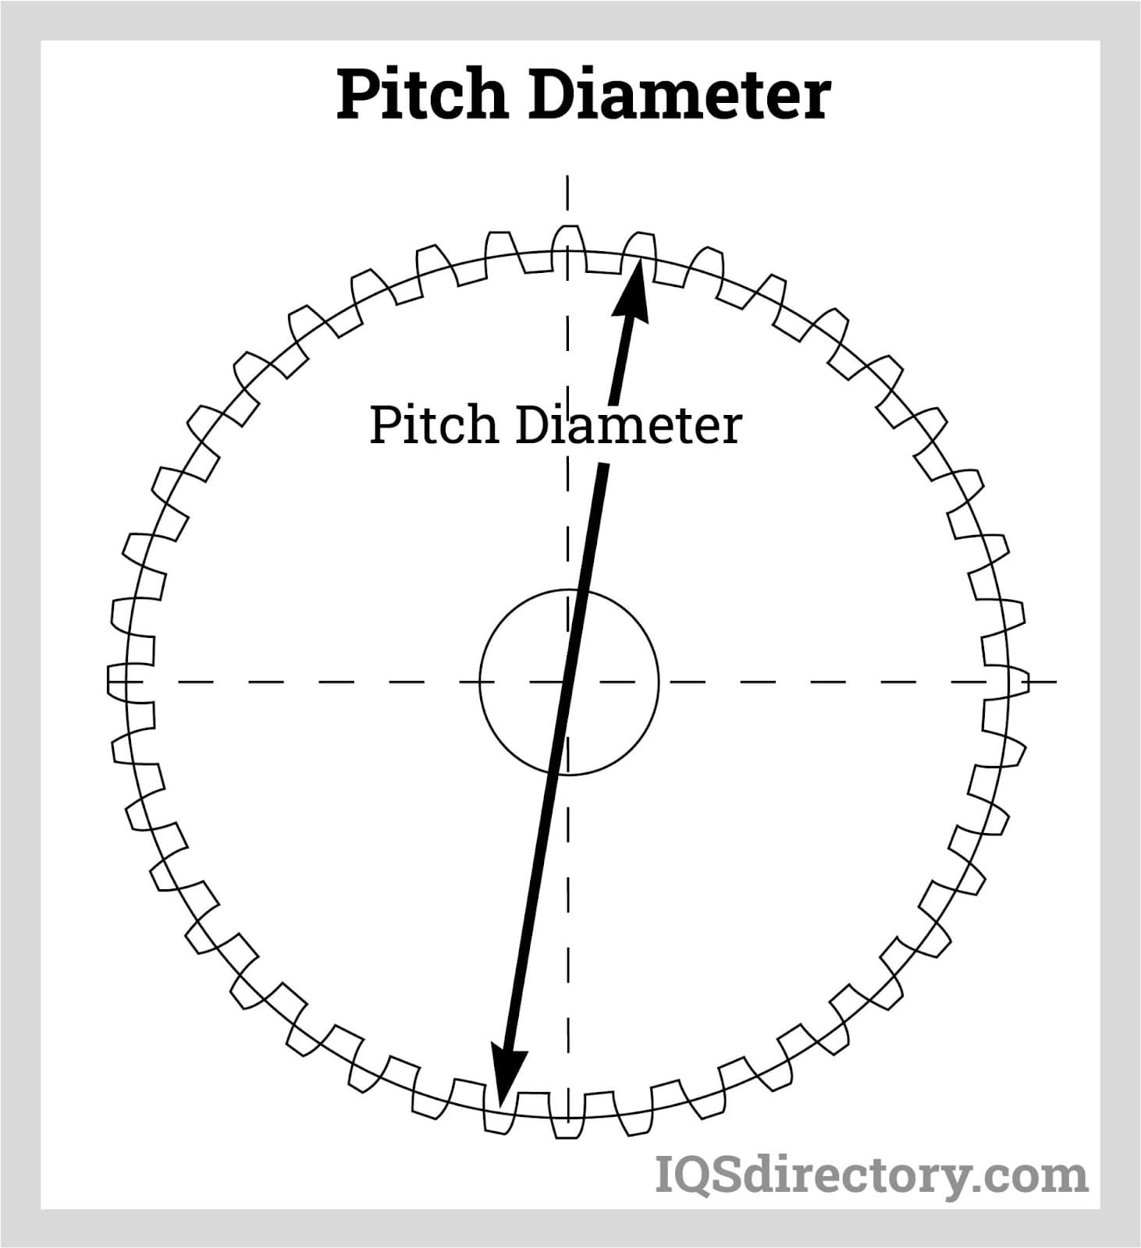

<https://www.youtube.com/watch?v=7PpiXc-PUY8&ab_channel=BrianLuu>

<https://www.youtube.com/watch?v=wCu9W9xNwtI&ab_channel=Lesics>

**Hub:** 20 teeth

140 mm diameter